**ICON**

Enhancements to DDAS Web Application

**QC Workflow**

**Brief Business Requirements**

Rev 1

21 Dec, 2017

Prepared by:

**Clarity Information Technologies Pvt. Ltd.**

Tel: +91-080-2529 1698, 4115 5410

Email: mail@claritytechnologies.com

# Revision History

|  |  |  |  |  |
| --- | --- | --- | --- | --- |
| **Revision** | **Date** | **Sections Changed** | **Summary/Description of Change** | **Author(s) of Change** |
| 1 | Dec/20/2017 | QC Workflow | Section revised – based on discussions with DD Team on Dec 19, 2017 | Patrick / Pradeep |
| 2 | Dec/21/2017 | QC Workflow | Revised – based on commented provided by DD Team | Patrick / Pradeep |

# Requirements

The existing DDAS Web application needs to be enhanced with the following additions.

1. QC Work Flow
   1. Arrangement to allow the junior resource to pass on their works to senior resource for review along with any comments and similarly, senior resource allowed to review as well as pass this back on junior resource with any review comments
   2. Provision for users to upload files during QC work flow, before the QC is completed with maximum file size being 5MB
   3. All comments from auditee and auditor should be stored in the tool for internal purposes and should be archived after 6 months along with the ICSF

# Proposed Solution

## QC Work Flow

QC Workflow section will provide a facility for a Due Diligence Team Member to QC the Compliance Forms of another team member.

A Due Diligence Team Member (Search Resource) can select a Compliance Form completed by self for QC Check and also identify a person (QC Verifier) who should do the QC Check. An Email alert will be sent to the QC Verifier.

The QC Verifier will have View access to the Compliance Form to be verified and will be able to provide feedback corresponding to the Findings inserted by the Search Resource.

Upon completion of the QC Check, the Search Resource may carry out changes to the Compliance Form and then mark the Compliance Form as ‘completed’.

QC Workflow

1. The Compliance Forms whose review is completed will be displayed in a page titled ‘Review Completed’.
2. The Search Resource will be able to mark a Compliance Form as ‘Completed’ or request for a QC Check.
3. The Compliance Forms marked as completed will be listed in a page titled ‘Completed ICSFs’.
   1. Facility to export the completed ICSFs to iSprint will be provided on the ‘Completed ICSFs’ page. This will be made functional when the DDAS-iSprint integration is implemented.
   2. Option will be provided to ‘Undo’ the ‘Completed’ status. Undo action will move the Compliance Form to ‘Review Completed’ page.
   3. Undo option will be active until the Compliance Form data is exported to iSprint. Thereafter the Undo option will be disabled.
4. The Search Resource will be able to assign a Compliance Form for QC (in the Review Completed page) and identify a QC Verifier, add a comment, drop down to select category (Standard or Priority) and optionally upload files related to the QC Check request.
   1. The Search Resource will be able to request one or more QC Checks.
   2. All the earlier QC Check Requests and the corresponding status will be displayed on the ‘QC Request’ request form. This is to inform the Search Resource about the earlier requests if any.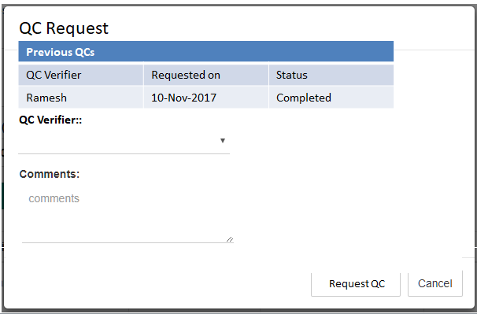
5. The compliance Form marked for QC will be listed in the ‘QC Check’ page.
   1. The Search Resource can undo the Request for Audit. Undo is permitted only till the QC Verifier picks the Compliance Form for QC.
   2. The application will send an email alert informing the QC Verifier to take up the QC. The mail subject and body will follow the pattern provided in Annexure – 1
6. The Search Resource and QC Verifier will be able to view the QC Check Requests related to them but admin will be able to view all the QC Check Requests.
7. The QC Verifier can login and open the Compliance Form for QC
   1. The starting page of the QC Verification Action will be similar to the following: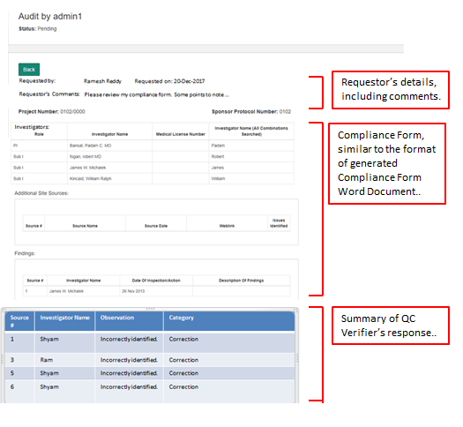

|  |  |  |  |  |
| --- | --- | --- | --- | --- |
| Serial No. | Investigator /Institute Name | Source Name | Category | Observation/Comment |
|  |  |  | Minor |  |
|  |  |  | Major |  |
|  |  |  | Critical |  |
|  |  |  | Suggestions |  |
|  |  |  | Others |  |

* 1. QC Verifier will be able to navigate through all the tabs of the Compliance: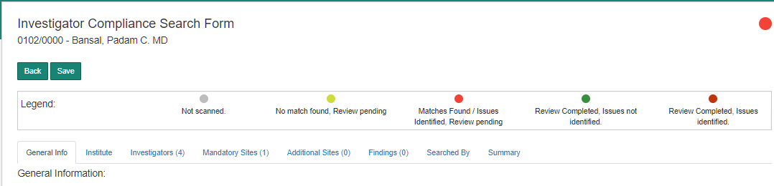

DD Team Comment - Can you please explain how the QC Verifier would move from the screen 7.a to 7.b ?

* 1. The QC Verifier will not be permitted to modify the contents of the Compliance Form created by the Search Resource.
  2. QC Verifier will be able to make observations on a Finding inserted by the Search Resource.

DD team comment - Along with this, QC verifier should be able to review all the websites and add observations/comments whether any findings were noted by the search resource or not.

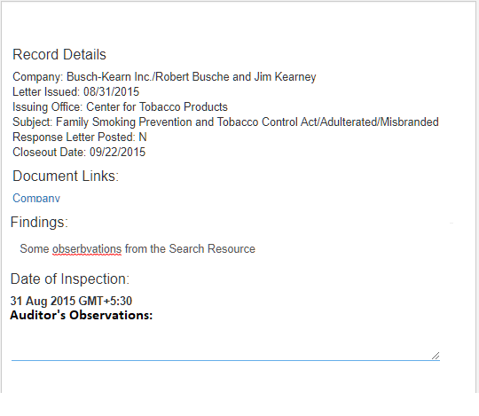 The following fields will be provided for the QC Verifier to provide observations.

* + 1. Comments
    2. Response Category (DDAS Team, Please provide the list of Response) – Table already provided above with categories.
  1. QC Verifier will be able to view the list of Full Match, Partial Match and Single Matches and add a Finding if required. 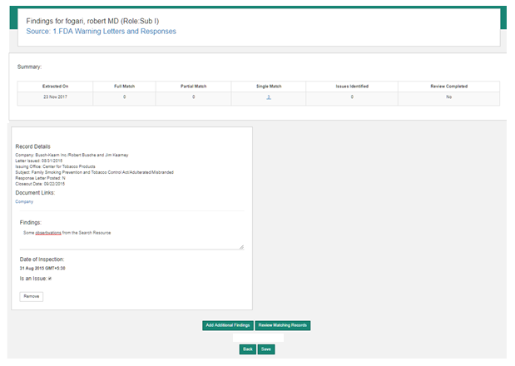
  2. QC Verifier will be able to insert a finding under Institute and Investigator-Site Findings sections.

The following fields will be provided for the findings inserted by the QC Verifier.

1. Comments

Response Category (DDAS Team: Please provide the list of Response)

1. The QC Verifier will mark the QC Check as completed and an email alert will inform the Search Resource about the status. The mail subject and body will follow the pattern provided in Annexure – 2
2. The QC Completed status will be displayed in the QC Check page.
3. Search Resource will be able to open the QC Report and respond to QC Observations made by the QC Verifier.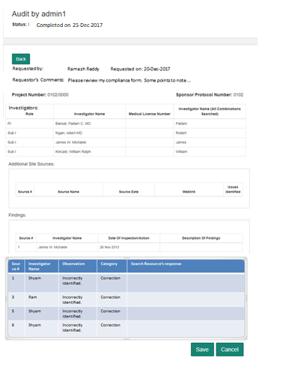

DD Team Comment – Can you please develop format on how it would look like on the search resource screen.

1. Search Resource will mark the Compliance Form as ‘completed’ and the Compliance Form will be moved to ‘Completed ICSFs’ page.

Annexure 1.

Email Format for mail generated when the Search Resource requests for an Audit.

DDAS Team to fill in the details below. Some parts of the mail body can be shown in bold.

Mail Recipients:

To: QC Verifier

CC:

Subject: QC Request – Request Category (Std or Priority)_ICON Study number_PI Full Name

Body:

Dear (QC Verifier Name),

(Search Resource Name) has requested you to review a compliance search outcome.

Please login to DDAS application and navigate to "QC Audits" to start the review.

DD team comment - If possible, can the direct link to the QC audit/review page be provided?

Yours Sincerely,

(Search Resource Name)

Signature:

Annexure 2.

Email Format for mail generated when the QC Verifier completes the QC.

DDAS Team to fill in the details below. Some parts of the mail body can be shown in bold.

Mail Recipients:

To: Search Resource

CC:

Subject: QC Complete – ICON Study number_PI Full Name

Body:

Dear (Search Resource Name),

Your QC review request has been completed by (QC Verifier Name).

Please login to DDAS application and navigate to "QC Audits" to view the observations/comments.

DD team comment - If possible, can the direct link to the QC audit/review page be provided?

Yours Sincerely,

(QC Verifier Name)

Signature: